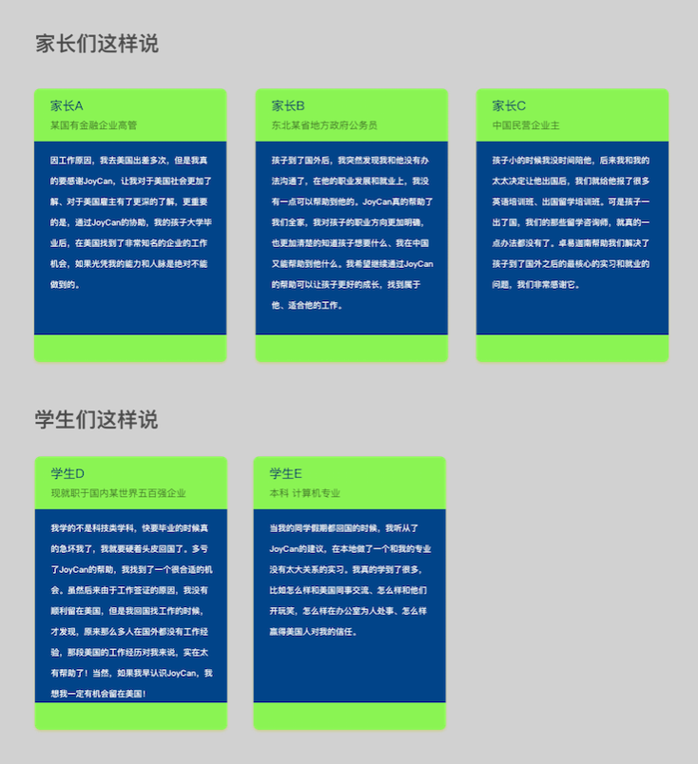

Parents’ testimonials:

Parent A (executive in a state-owned financial corporation)

I go on business trips often to the US, and I have to thank JoyCan for helping me blend in to and navigate the American culture. Thanks to JoyCan, I am now more familiar with American social and occupational circumstances and it is very helpful in my business dealings. More importantly, my kid secured a job with a very famous company with the help of JoyCan after graduating from university. I truly thank JoyCan for that.

Parent B (a government officer in a province in Northeast China)

Since my son went to the US for college, we had grown farther apart. I found it hard to talk to him, especially when it comes to his future and employment issues. I didn’t think there was much I could do, but it turned out that working with JoyCan helped us so much. I now understand more about what my son has experienced, what he wants, and what is out there for him. Now that we work with JoyCan, I have a clearer vision of my son's future and a better understanding of him and how I can help him achieve his goals.

Parent C (Chinese business owner)

We didn't spend much time with our daughter when she was younger, as we were always tied up with work. Ever since we decided to send her abroad for university, we signed her up for various language training courses and worked with an agency for school applications. While that helped her get in to university, now that she’s graduating, we realized there's not much available to help her make the leap into the US workforce. Luckily, we found JoyCan to assist her with transitioning to an internship or a job in the US. We have found JoyCan to be truly helpful.

Students’ testimonials:

Student D (employee of a Fortune 500 company in China)

I wasn't a STEM major and I remembered how anxious I was upon graduation. I felt I had no choice but to return to China after graduation. I began working with Joycan, albeit rather late, and thanks to them, I did get a job offer in the US. Unfortunately, I couldn't get a work visa. Upon my return, it startled me that so many international students have no work experience during their study abroad. If I had begun with JoyCan earlier, I could have better secured a job and met all the necessary legal requirements to work in the US. If only I knew earlier.

Student E (undergraduate, computer engineering)

While most of my friends returned to China during summer breaks, I decided to take an internship as JoyCan suggested. This has been incredibly valuable. I gained so much on-the-job experience, including some of the intangible aspects, such as how to communicate effectively with my American colleagues, how to tell jokes at work, and how to gain trust and respect from my coworkers. I love my job.